EDS Theory Activity no.1

Name : Parth Isekar

Roll No: CS7-09

Prn : 202401080062

MY dataset : IPL

IPL Dataset Assignment

Using NumPy and Pandas

Code with Output

import numpy as np

import pandas as pd

# Load dataset using pandas

ipl = pd.read_csv('deliveries.csv')

# 1. Find the total number of deliveries bowled using pandas

print("Total Deliveries Bowled:", ipl.shape[0])

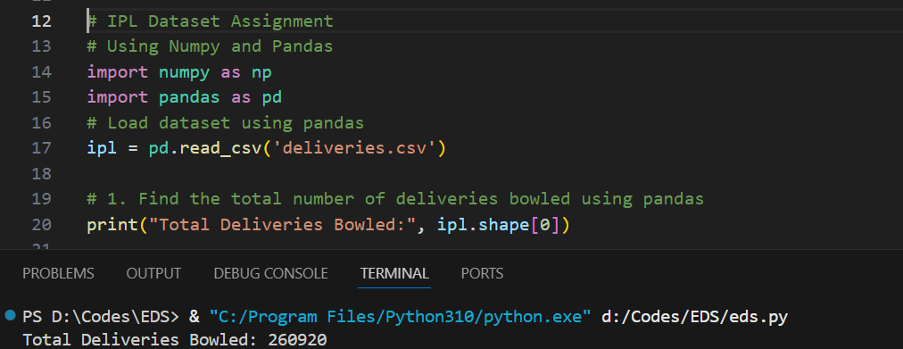

# 2. Find the total number of matches played using pandas

print("Total Matches Played:", ipl['match_id'].nunique())

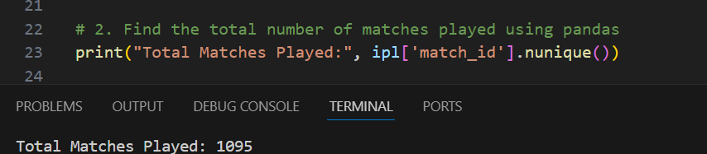

# 3. List all unique batting teams using pandas

print("Unique Batting Teams:", ipl['batting_team'].unique())

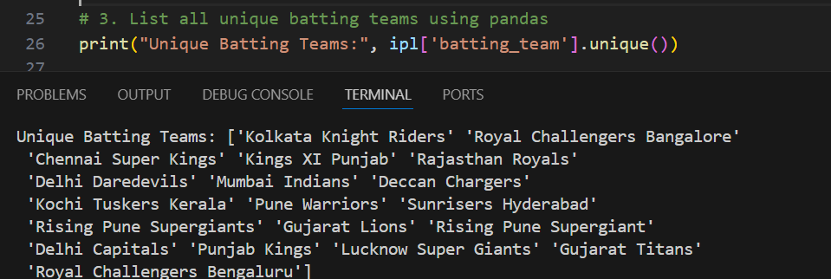

# 4. List all unique bowling teams using pandas

print("Unique Bowling Teams:", ipl['bowling_team'].unique())

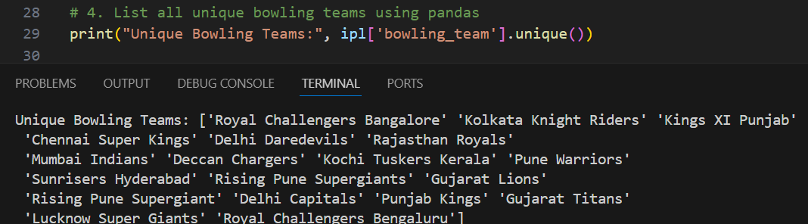

# 5. Find the player who scored the maximum total runs using pandas

print("Top Run Scorer:", ipl.groupby('batter')['batsman_runs'].sum().idxmax())

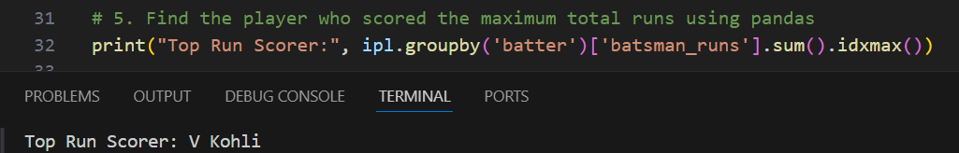

# 6. Find the bowler with the most wickets using pandas

print("Top Wicket Taker:", ipl[ipl['is_wicket']==1]['bowler'].value_counts().idxmax())

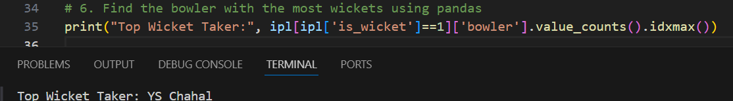

# 7. Find total runs scored by each team using pandas

print("Total Runs by Each Team:\n", ipl.groupby('batting_team')['total_runs'].sum())

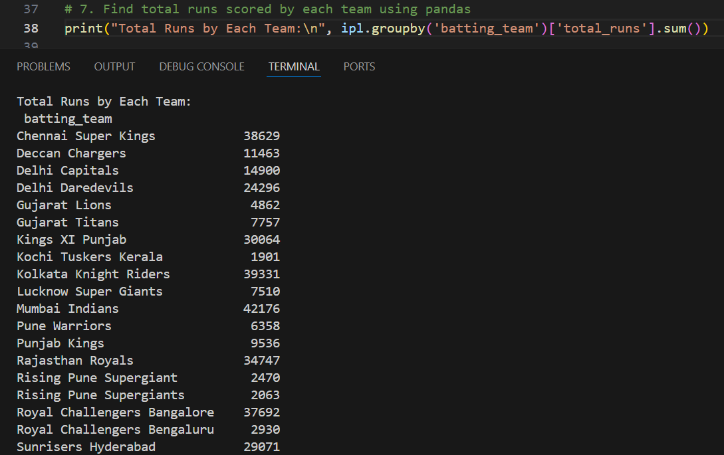

# 8. Find the player who hit the most sixes using pandas

print("Player with Most Sixes:", ipl[ipl['batsman_runs']==6]['batter'].value_counts().idxmax())

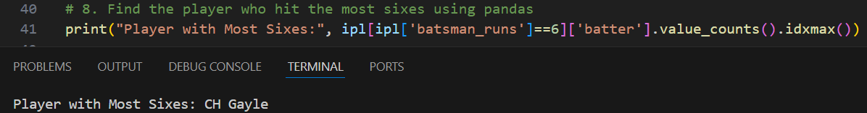

# 9. Find number of dismissals by "caught" method using pandas

print("Total 'Caught' Dismissals:", ipl[ipl['dismissal_kind']=='caught'].shape[0])

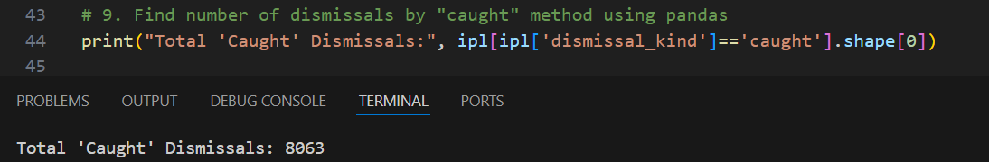

# 10. Find the bowler with most "bowled" dismissals using pandas

print("Top 'Bowled' Dismissal Bowler:", ipl[ipl['dismissal_kind']=='bowled']['bowler'].value_counts().idxmax())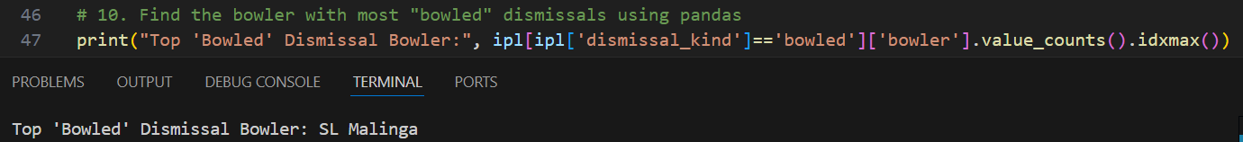

# 11. Find total extras given by each team using pandas

print("Total Extras by Each Bowling Team:\n", ipl.groupby('bowling_team')['extra_runs'].sum())

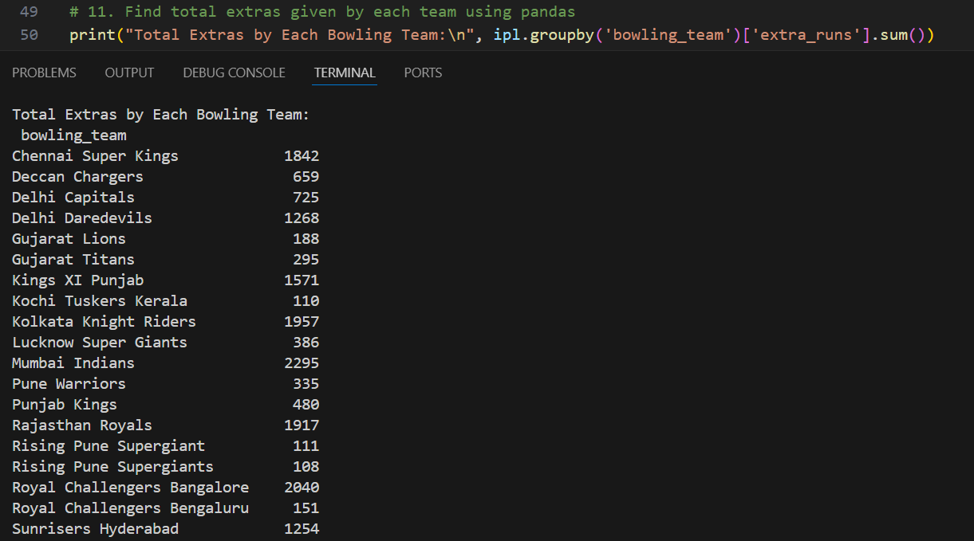

# 12. Find the player with maximum runs in a single match using pandas

print("Top Scorer in a Single Match:", ipl.groupby(['match_id', 'batter'])['batsman_runs'].sum().idxmax())

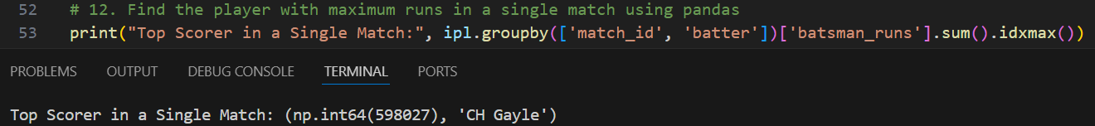

# 13. Find total number of boundaries (4s) scored using pandas

print("Total Boundaries (4s) Scored:", ipl[ipl['batsman_runs']==4].shape[0])

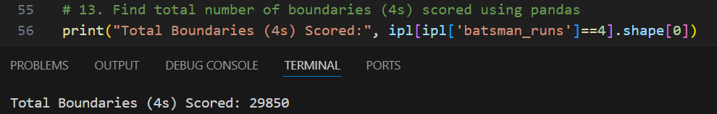

# 14. Find number of overs bowled by each team using pandas

print("Overs Bowled by Each Team:\n", ipl.groupby('bowling_team')['over'].nunique())

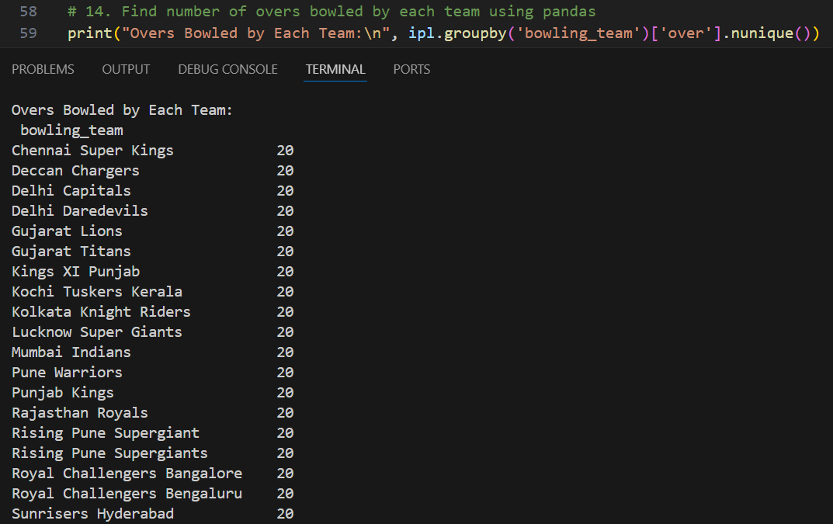

# 15. Find top 5 bowlers with least economy rate using pandas and numpy

# Economy = Total runs conceded / overs bowled

# Using groupby() from pandas and calculations using numpy

economy = ipl.groupby('bowler').apply(lambda x: np.sum(x['total_runs']) / np.unique(x['over']).size)

print("Top 5 Economical Bowlers:\n", economy.sort_values().head(5))

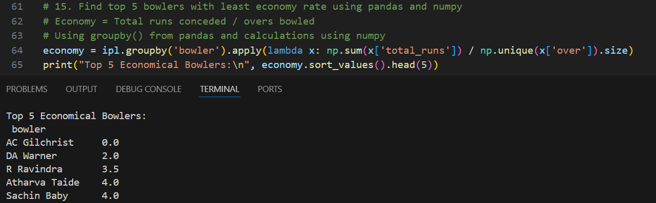

# 16. Find the batting team with highest total runs in a single match using pandas

print("Team with Highest Runs in a Match:", ipl.groupby(['match_id', 'batting_team'])['total_runs'].sum().idxmax())

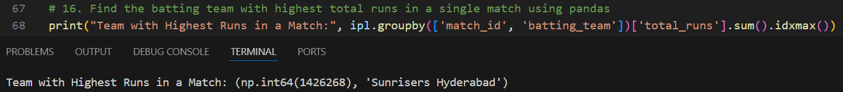

# 17. Find average runs scored per over for each team using pandas

print("Average Runs per Over by Each Team:\n", ipl.groupby('batting_team')['total_runs'].sum() / ipl.groupby('batting_team')['over'].nunique())

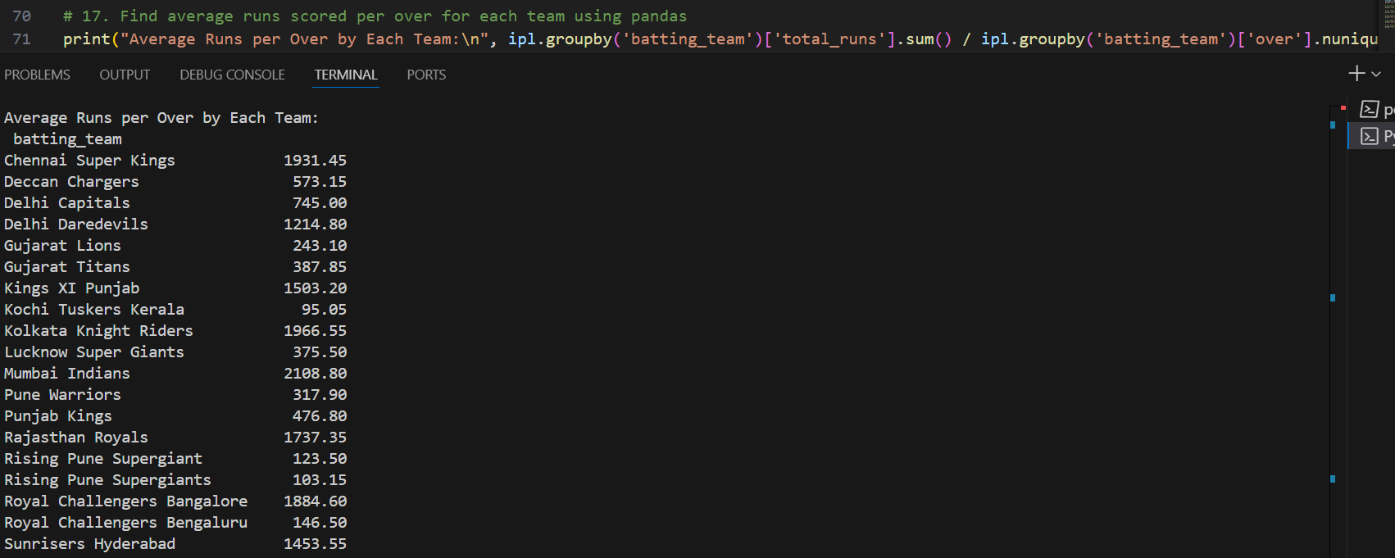

# 18. Find how many times a player got run out using pandas

print("Run Out Count by Player:\n", ipl[ipl['dismissal_kind']=='run out']['player_dismissed'].value_counts())

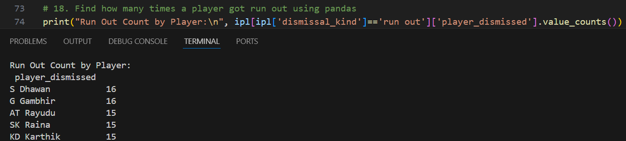

# 19. Find match with the maximum number of sixes using pandas

print("Match with Most Sixes:", ipl[ipl['batsman_runs']==6]['match_id'].value_counts().idxmax())

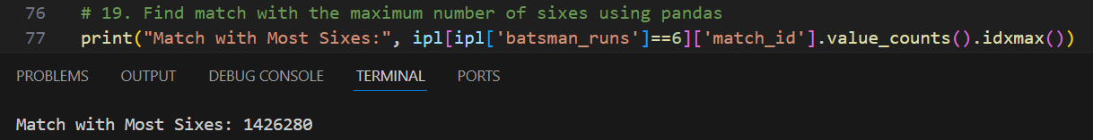

# 20. Find the fielder with most dismissals using pandas

print("Top Fielder in Dismissals:", ipl['fielder'].value_counts().idxmax())

